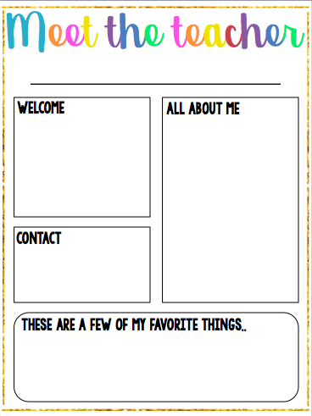

- You can contact me via my school email [westoco@Richmond.k12.ga.us](mailto:westoco@Richmond.k12.ga.us) or call the school at 706-592-4090.

-I will send out an invitation text to parents asking you to sign up for my Remind account.

Auburn Football

Hands on Activities

Photography

Dr. Pepper

Hello and Welcome to my class! This year I am teaching First Grade through Fourth Grade for ELA and Math. I look forward to an exciting and fun year full of adventures!

Hello! This is my third-year teaching in Richmond County. I graduated from Augusta University with a degree in P-12 Special Education. I have had experience in the Co-teaching model, self-contained, and resource settings for grades K-5.

About the Classroom

Students will have homework Monday-Thursday. I will send home weekly/monthly newsletters, updating parents on what is being taught within the classroom, activities in the classroom and school, and other important information. It will also include suggested daily practices. Daily behavior sheets will be sent home, parents are asked to review them with the students and send them back to school signed.

Ms. Weston